**TRAINING PROPER**

**PROFILE OF THE COMPANY / ORGANIZATION**

1

vi

vi

vi

vi

vi

ii

ii

vi

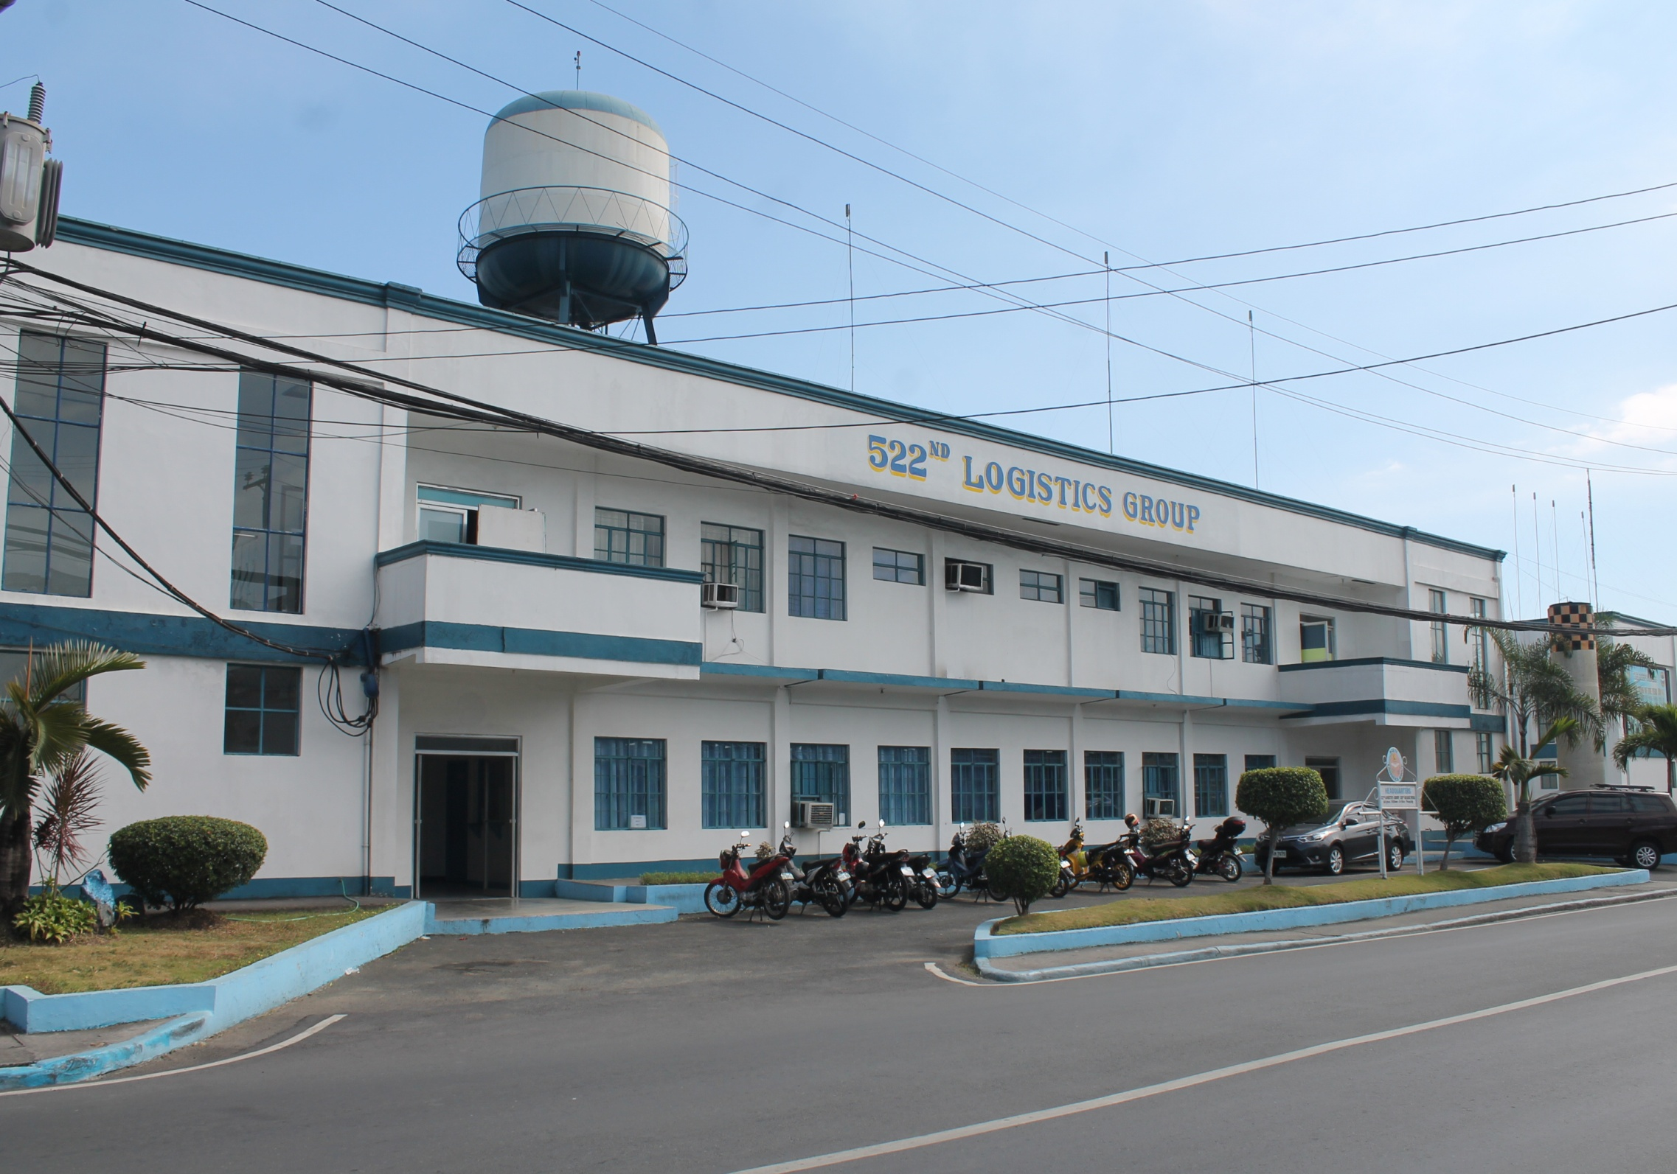

**522nd LOGISTICS GROUP PROFILE**

The 522nd LOGISTICS GROUP of the 520thAIR BASE WING was activated on 15 July 2012 commissioned to provide responsive and quality logistics support to accomplish the Wing mission. It is composed of three squadrons, namely: the 5221st Civil Engineering Squadron, the 5222nd Motor Vehicle Squadron and the 5223rd Supply Squadron. As it continuously endeavors to support the Wing’s mission to provide, operate, maintain Base services and facilities and to secure and defend Colonel Jesus Villamor Air Base, the premiere PAF Base and the “Home of the Headquarters Philippine Air Force” at all costs, its performance is set towards realizing the vision as the leading logistics provider of Base services in the Philippine Air Force.

**MISSION**

2

To provide logistical support, operate and maintain base-wide services, facilities and security of Colonel Jesus Villamor Air Base Complex

**VISION**

Our vision is to be Southern Tagalog’s number 1 Toyota Dealer, and to make the Toyota brand number 1 in our region.

**CORPORATE PHILOSOPHY**

With the “Right man to the right job”, the untiring effort of its men and women to provide logistics support to PAF personnel, civilian employees, dependents, government agencies and other stakeholders, the 522nd Logistics Group has greatly contributed to the 520th Air Base Wing for having won the most coveted CG, PAF Streamer Award 2012, 2013 and 2014 in Support Wing Category for three (3) consecutive years the Group performed all its best soaring high to attain its mission and vision with par excellence.

With its Action Plan 2028, the Group is shaping towards the future flying high from its humble beginnings into a modernized Air Force as it continuously keeps CJVAB in pace by instilling new systems and approaches in the accomplishment of its mandated mission. The Group’s action plan System Over Air Base Responding High In Government Housekeeping (SOAR HIGH PAF) details the comprehensive plan of the Group to systematize the tasks at hand.

**ORGANIZATIONAL CHART**

3

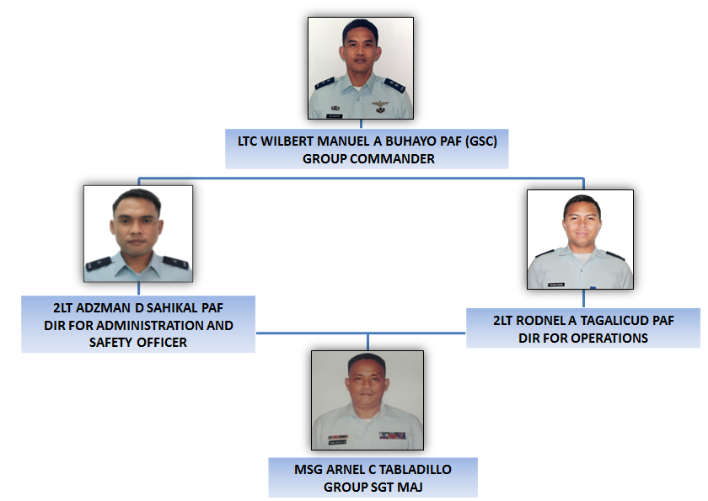

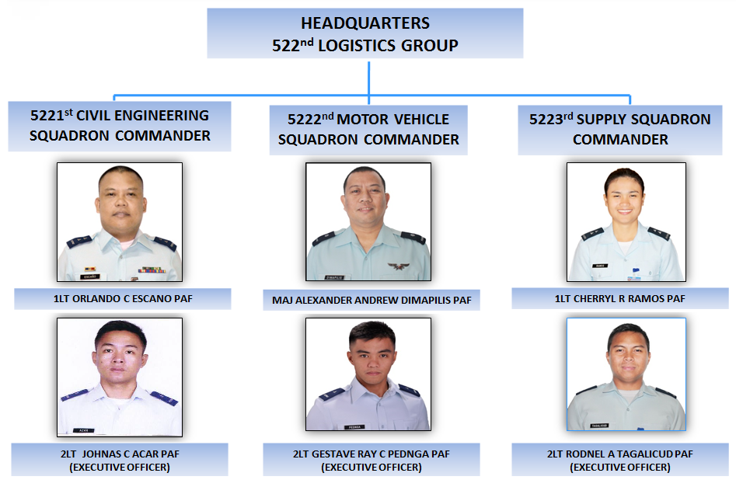

**TRAINING EXPERIENCE**

4

Having the On Job Training at 522nd Logistics Group, the Trainee have learn a lot of experience and challenge, the trainee applied the knowledge and his skills being an Information Technology Student in doing the tasks given to him in terms of technical skills in computer such as troubleshooting, making presentations, excels etc.

The trainee started the On Job Training On April 27, 2015 at 522nd Logistics Group Office at Col Jesus Villamor Airbase,Pasay,City. On the first day, Msg. Leo Mar Esposo PAF orient them about the company rules and regulation in Toyota. The HR supervisor Mrs. Ma. Cristina L. Torres gives the plan of the system that the trainee needed to do. Mr. Jerome A. Collo, an I.T Assistant guide the trainee about the system needed to do.

The trainee arrived at 6:45 in the morning at Human Resource Department at Toyota San Pablo the trainee was so excited to do the task assigned to him. Exactly 8:00 am the trainee start doing the task and because in the HR Department has a network connections the trainee browse for some code that is needed.

The trainee experienced a lot of things in the On Job Training such as being a responsible to do the task and to be able to learned and gain new knowledge, and to improve the skills of being an Information Technology Student. The trainee is thankful and greatly honored for this wonderful opportunity that our Supervisors and Staff taught them.

**INSIGHTS**

5

OJT’s can bring fresh ideas into the organization. Given the opportunity tospeak their minds freely and without fear, they maybe able to contributesignificantly in brainstorming sessions or research and eventually help improve the organizations productivity. While training the interns, employers are in fact also teaching their employees to process of guiding the trainees stretches their patience, develops teaching skills and makes them more sensitive to the needs and mind set of the younger generation. The course of supervision also teaches them how to share what they know and be receptive to questions. Hence, the internship also becomes an avenue in training for future managers of the company.

Proper attitude towards other people is essential to be in a team and to have harmony relationship with your colleagues or co trainee. This Training helped the trainee managing their time, following the rules and duties as their trainee. It also helped the trainee to practice their skills and knowledge about different works. Skills like communication, interpersonal and technical skill. As we all know On Job Training is one of the requirements of graduating student so the trainee must accomplish 486 hours of On Job Training to the company. But the trainee should know that On Job Training is not just a requirement.

Accommodating on-the-job trainees can truly be beneficial not only to the trainees but also to the companies that provide opportunities for this type of learning. There is wisdom in the front lines. Such training can be an investment that will be valuable to the company later on. This is also why trainees should take their internship seriously as it can become a powerful tool and possibly even a source of recommendation when they take that big lift from being students to career professionals.

**SUMMARY**

6

As a graduating student who is taking up Bachelor of Science in Information Technology, the course requires us to undergo the On-the-Job Training as part of the curriculum. And this activity will help us to enhance our skills and to succeed in our future workplace.

This activity is one of the most unforgettable and remarkable periodin trainees life. It is the time when a student has to adjust himself to the nature of the agency where he belongs. During those days the trainee has to work during office hours, working the task he was assigned to, and dealing with supervisor and other office staffs. On-the-Job Training was not really an easy task at all. The trainee realized that working is not an easy job and that every person differs in so many ways.

This activity helped the trainee a lot on his personal growth as well as boosts himself-confidence. It was a fruitful and enjoyable despite those hardships and problems he has encountered. It really enriched his knowledge and skills. It gave him also strength to face those trials that awaits him after graduation. This will serve as his stepping-stone to fulfill all his goals in life.

**RECOMMENDATION**

7

1. **To The Students**

The 522nd Logistics Group Office created a good service to their clients and gave the best training for the students. The students must have a good company that would give them a good training ground and would enhance their knowledge and capabilities. The school must have o good coordination for some companies that offer an annual On the Job Training inside their company. One of the best ways of training is in the city training that would give different experiences to the trainees. An out of town training would give more self-esteem to the students.

1. **On The Practicum/OJT**

On Job Training help students to have an idea what field they are going through. And it’s give the student as On Job Training for preparation for their future. It will enrich their knowledge as On Job Training. I recommend to the company to continue their On Job Training for the students to gain and improve the skills and knowledge and I recommend to give a proper compensation/ allowance and recognition enable them to motivate and finished the program.

1. **On The Curriculum**

Practicum coordinator should closely monitor the students and partner industry regarding the performance of-the-job training. OJT Program requires work supervisors who are not just practitioners but educators as well. OJT is an educational program involving a learning process with teaching strategies. Therefore, the transfer of knowledge and skill depends on the knowledge, skills, standards and values of the trainer and/or work supervisor.

APPENDICES

**ENDORSEMENT LETTER**

8



**Acceptance letter/form**

9



14

**DUTIES AND RESPONSIBILITIES**

* Will do some office related processes such as encoding, making presentations, printing, photocopying and filing of documents.
* Will also answer calls and transfer.
* Helps with encoding of reports.
* Assists employees & co-OJT .
* Monitors their Vehicle Tracking System.
* Troubleshooting.
* Will comply other instruction delegated by our supervisor.

**CERTIFICATE OF COMPLETION**

15



**WORK SAMPLES**

16

25

**DOCUMENTARIES/PHOTOGRAPHS**

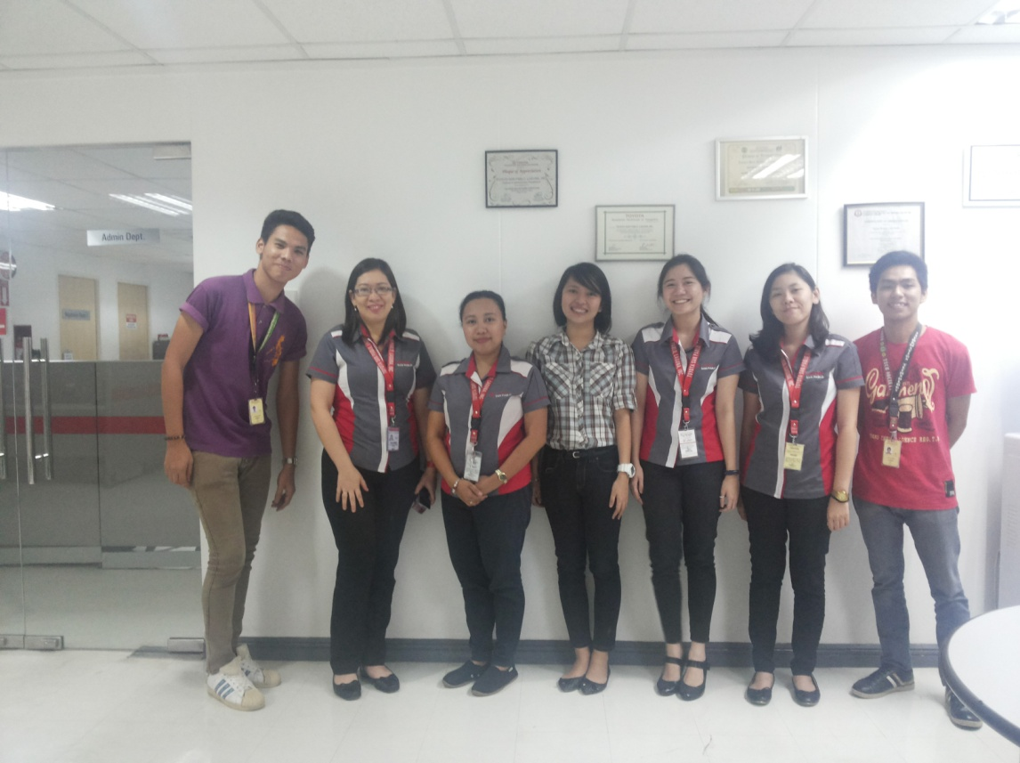



**Figure 5**

HR Staff and OJT

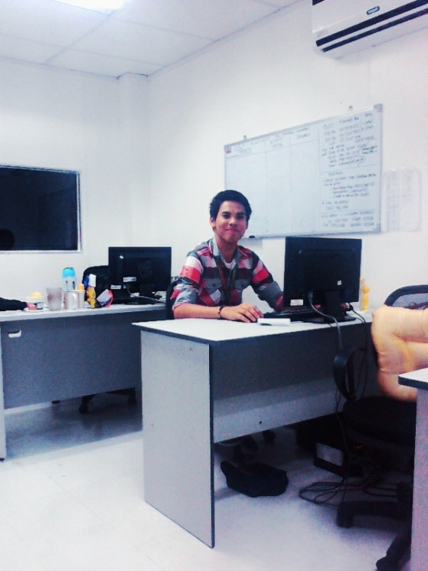

**\**

26

**EVALUATION FORM**

